**Ex3andEx12Chp6**

**Exercise 3-Chapter 6**

In the underlying model of Fig. 6-4, it is assumed that packets may be lost by the network layer and thus must be individually acknowledged. Suppose that the network layer is 100 percent reliable and never loses packets. What changes, if any, are needed to Fig. 6-4?

The network layer will become 100% reliable if you remove the passive establishment pending because it is not dependent on the acknowledgement and so transactions happen immediately.

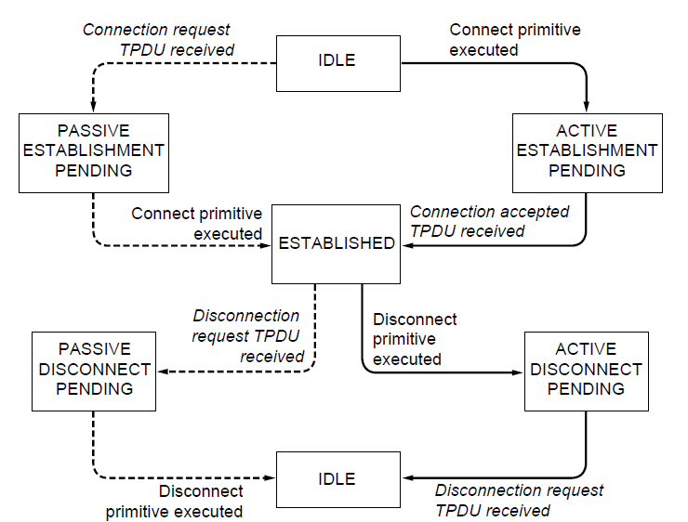

**Figure 6-4. A state diagram for a simple connection management scheme. Transitions labeled in italics are caused by packet arrivals. The solid lines show the client’s state sequence. The dashed lines show the server’s state sequence**

**Exercise 12-Chapter 6**

In Figure 6-20, suppose a new flow E is added that takes a path from R1 to R2 to R6. How does the max-min bandwidth allocation change for the five flows?

It will change to:

A – ½ on links R1R2 and R2R3

E – ½ on links R1R2 and R2 R6

B – 1/3 on links R4R5, R5R2, and R2R3

C – 1/3 on links R4R5 and R5R6

D – 1/3 on links R4R5 and R5R6

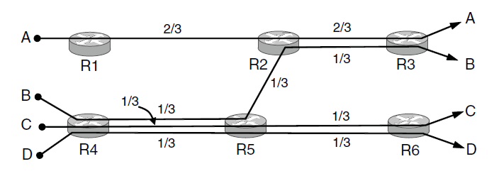

**Figure 6-20. Max-min bandwidth allocation for four flows**